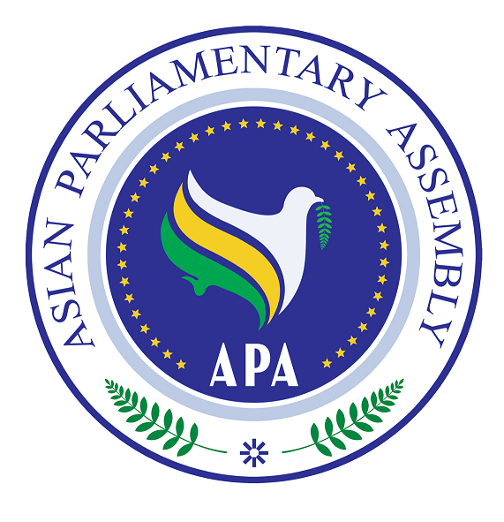
Asian Parliamentary Assembly (APA)

REGISTRATION FORM
Coordinating Meeting of Asian Parliamentary Assembly
on the sideline of the 141st IPU Assembly
Sava Center- Hall 3/0, G/F
Belgrade, Serbia
( Sunday, 13 October- 09:30-11:00)

Please fill in one registration form for each participant (in block capitals) and return it to APA Secretariat at the following address by September 23, 2019 the latest.
- Delegation of: …………

- Title: Please check Mr. Ms. Dr. other
- First Name:
- Last Name:

- Position in the parliament
……………………………………………………………………………………

- Phone No. | - …………………..……………………………………………..  - Country Code City Code Number
- Cell phone  - Fax No. | - …………………………………………………………………  - ………………………………………………………………..
- Email Address: | - ……………….……………………………………………..

Any Proposal on Emergency Item:

